Assignment 3 (OS Lab) CS191092 4B1 Poorab Gangwani

Name = Poorab Gangwani

Class = 4B1

Roll-Number = CS191092

Question 1

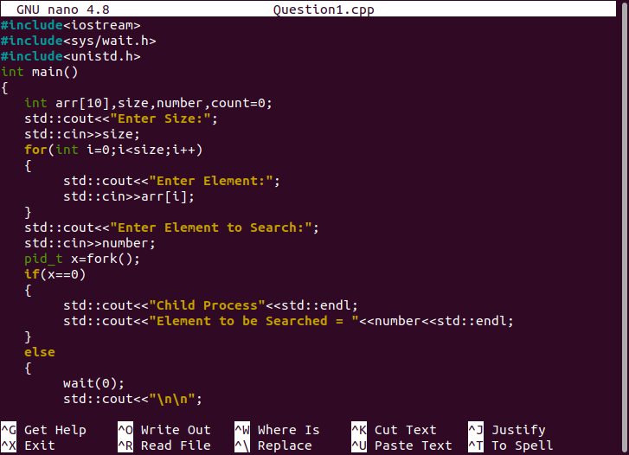

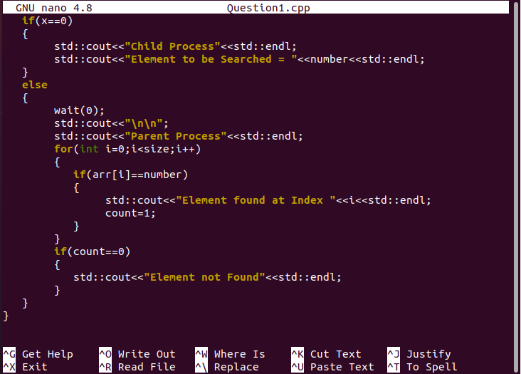

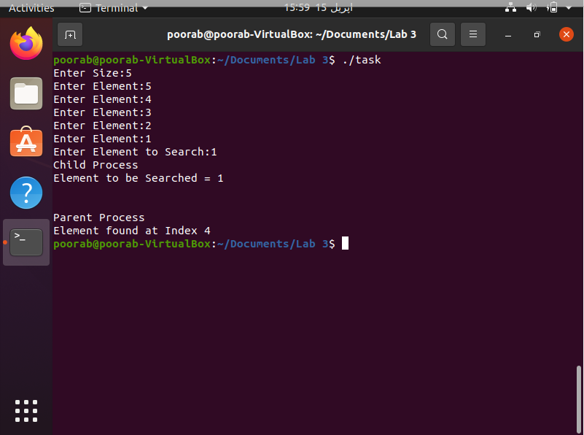

Question 2

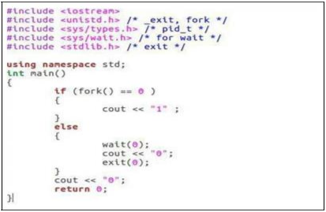

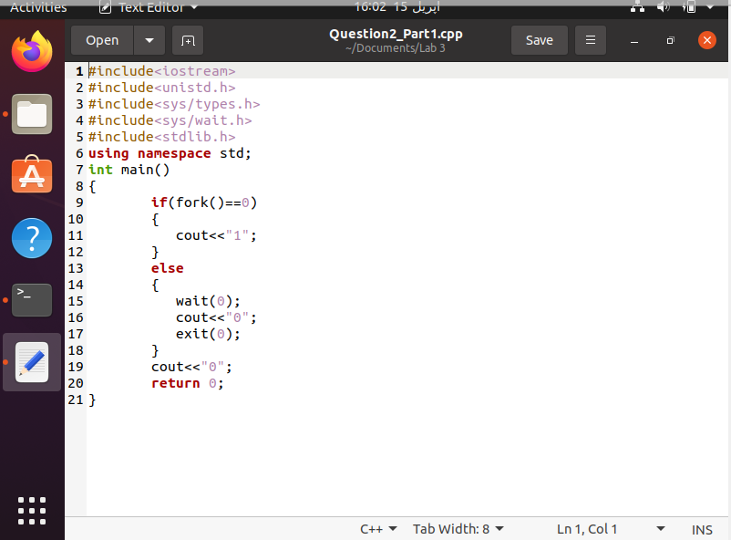

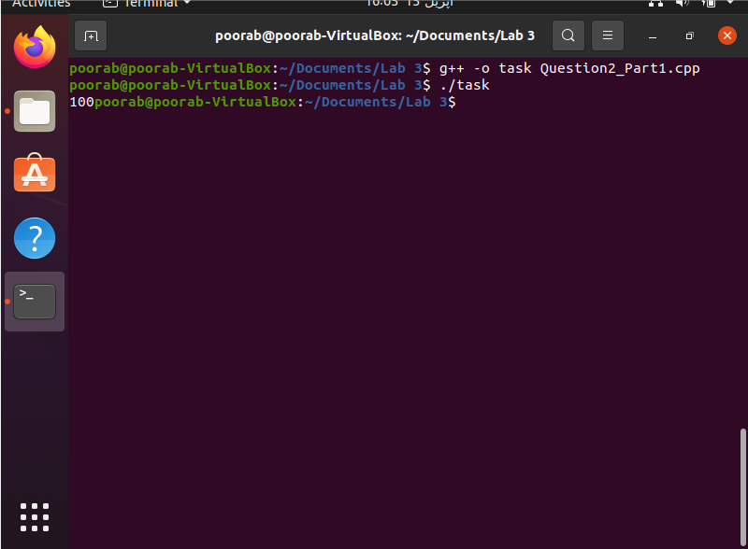

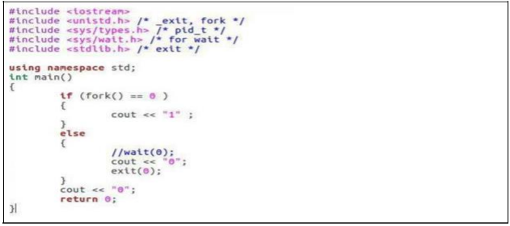

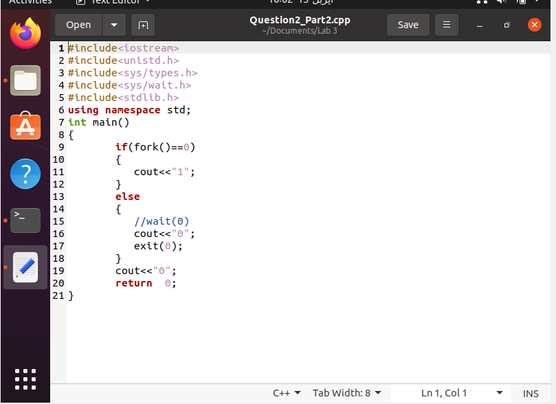

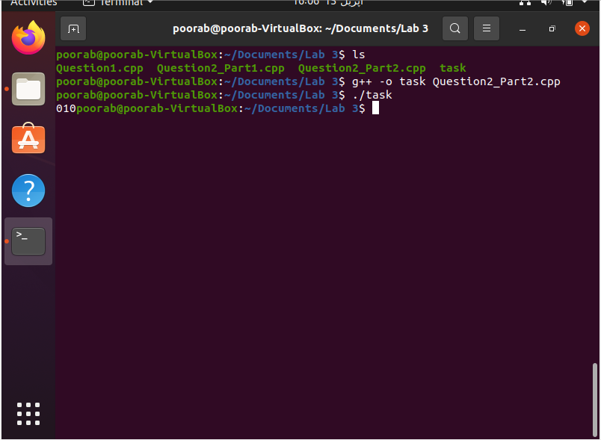

Solution:

1. The difference between the codes is that in the 1st Code, the wait() command is applied which is why the flow of execution transfers to child process and prints ‘1’ and afterwards prints ‘0’ that is written before return 0 line and then returns to the parent process and resumes from after the wait() command and prints ‘0’ in the else command and then exits
2. In the second code , since the wait() command is disabled then the ‘0’ in the else portion (parent process) will be executed and then with exit(0) the parent process will end and cout<<”0” will not print before return 0. Afterwards if portion (child process) will be invoked and ‘1’ will be printed and afterwards the line “cout<<’0’;” before return 0 will print.